Revision Notes
To help you remember key information, you need to organise your notes. This means taking your notes from lessons, home learning, and independent reading and putting them in a format that makes sense to you.
Key Tips
- Make use of sub-headings, bullet points, and diagrams
- Write in note format, rather than complete sentences
- Identify the most useful information that you’ll need to remember
Lord of the Flies
Theme: Civilisation vs Savagery
- Civilisation: Ralph, Piggy, Simon, Samneric, the conch, Piggy’s glasses, fire on the mountain
- Savagery: Jack, Roger, Bill, spear, hunting, masks, painted faces, Castle Rock, fire on the beach
Key Quotations
‘Samneric protested out of the heart of civilization, "Oh, I say!—honestly!"’
‘found themselves eager to take a place in this demented but partly secure society’
- Organise and group in logical sections
Example

Format of Revision Notes
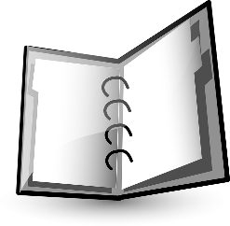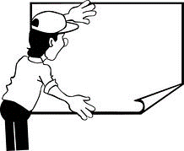
Flashcards Notebook Ring binder Posters Electronic

Areas to Revise
English Language
- Read widely of fiction and nonfiction texts: short stories, newspaper articles, autobiographies, travel writing, letters, speeches, etc.
- Practise writing creatively: look up new words, experiment with figurative language and persuasive techniques.
- Write in different formats: stories, formal letters, speeches, articles, descriptions, etc.
- Revise punctuation and how to use it accurately, and for effect.
- Practise tricky spellings
- Make sure you know the format of the exam papers and what skills you need to demonstrate in each section.
English Literature
- Reread your set texts
- Complete AFILM on each poem (About, Form & structure, Imagery, Language techniques, Mood and atmosphere)
- Make Venn diagrams that compare and contrast poems with similar themes and ideas
- Read unseen poetry and practise doing AFILM on it
- Revise literary terminology
- List the key themes of your novels and play, with examples
- Do a character profile of all of the major characters of your texts
- Create lists of key quotations for each text that you then memorise
General Revision
- Complete practise questions
- Check out specific revision guides, such as those by CGP and CUP
Further help
- If you have any questions about your course, or your learning, please speak to your class teacher or to Ms Jones (Head of English)
- There are folders on the main English Edmodo group with revision materials and links
- After school English revision sessions will start in January 2017
- http://www.litcharts.com/
- http://www.bbc.co.uk/education/levels/z98jmp3
- http://www.aqa.org.uk/student-support/for-students

Specific areas to revise for your assessment

